Setup TypeScript Environment
Note: This setup assumes the following software already installed
- Web Browser (Edge, Chrome, Brave, etc…)
- Latest NodeJS
- Latest Visual Studio Code

- Adding Extensions to Visual Studio Code
  - Start Visual Studio Code
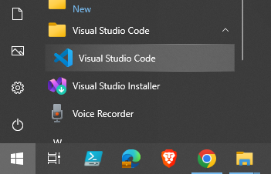
  - In Visual Studio Code, Select Extensions
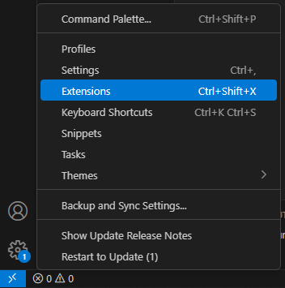
  - Install ESLint.
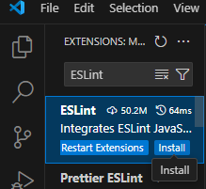
  - Install Prettier ESLint.
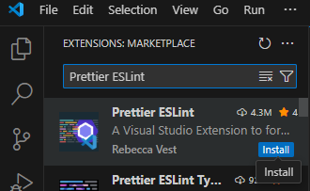
  - Install Path Intellisense.
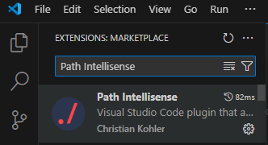
  - Install Angular Language Service (This is only for Angular development)
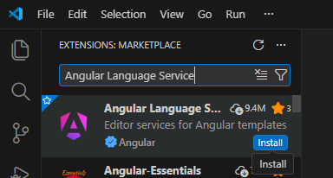
  - Close Visual Studio Code
- Install TypeScript Compiler
  - Click Window Start button.
  - When the menu appears, just type cmd and select Run as Administrator.
  - Under the command box, type npm install –location=global typescript.
Wait until the following appears.
  - Leave this command window remains open.
- Setting up new project environment
  - Type the following commands in the previous command window. (In case no command window, start a new one with admin right again).
  - Type and run the following commands one by one:
➢cls
➢ cd\
➢ md proj
➢ cd proj
➢ code . (There is an empty space in between code and dot)
Now you should open the project folder from Visual Studio Code.
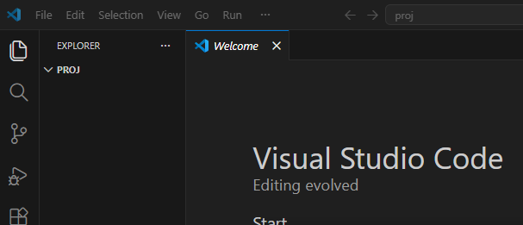
  - Move the move cursor to the PROJ folder under the Explorer, you should see few icons appear
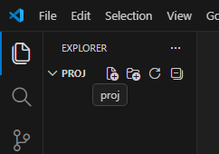
  - Click New File.
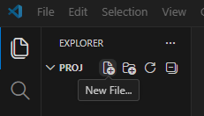
  - Give the file name as ex101.ts. Press Enter.
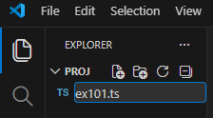
  - A new empty TypeScript file was created.
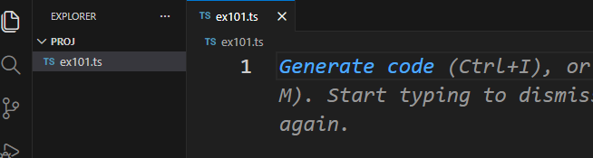
  - Type the following code and save the file:
class Greeting{
greet():void{
console.log("Hello World!!!")
}
}
var obj = new Greeting();
obj.greet();
  - Create new Terminal window.
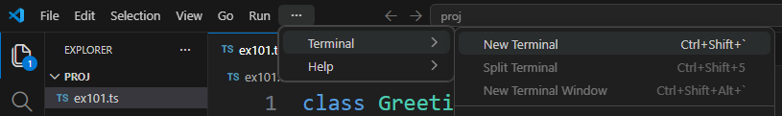
A terminal window will appear at the bottom of the editor
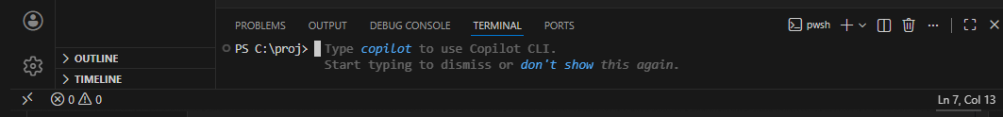
  - Right-click to rename the terminal window as TSC (This window is for the TypeScript compiler).
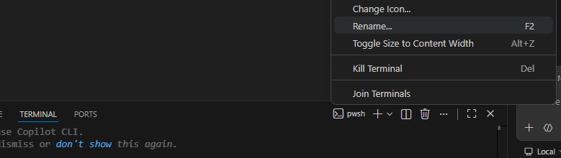
  - Type the command tsc ex101.ts in the terminal Window. Upon successful compilation, there will be a new file ex101.js generated.
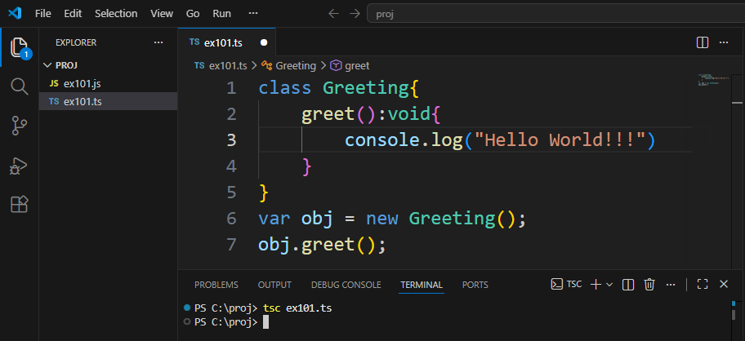
At this point, TypeScript compiler is confirmed installed and work properly.
Notes: In case you are having problem with running script under VS Code, follow the following steps:
➢ Close the Visual Studio Code
➢ Press the windows-button on your keyboard
➢ Type 'PowerShell'
➢ Right-click Windows PowerShell and Run as Administrator
➢ Run the following command and confirm with ‘Y’
Set-ExecutionPolicy -ExecutionPolicy RemoteSigned -Scope LocalMachine
➢ Close the PowerShell Window
➢ Restart the Visual Studio and repeat the step that caused error.
for more information: https://www.roelpeters.be/solved-running-scripts-is-disabled-on-this-system-in-powershell/
- Testing Program
  - Create a new ex101.html file.
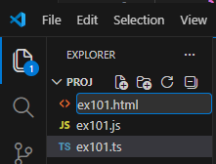
  - In the ex101.html editor, type html:5 then press Enter. HTML script is auto generated for you. Change and add the following:
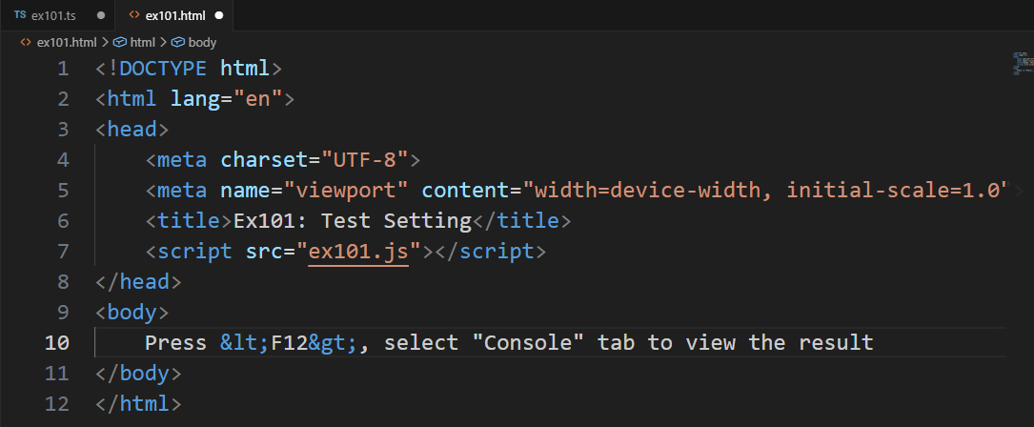
Save the file
  - Start a new terminal and rename it as Server. Now you should have 2 terminal windows.
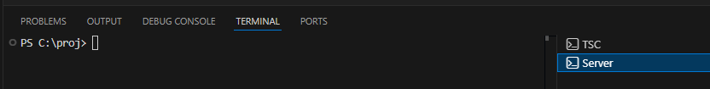
  - Under the “Server” terminal, type the command npm init. Just press Enter to use all default values.
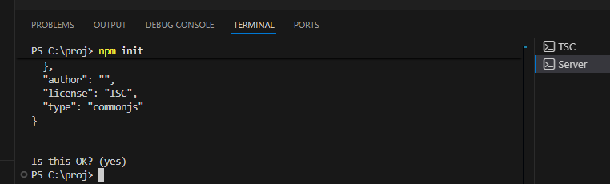
A new package.json file is generated
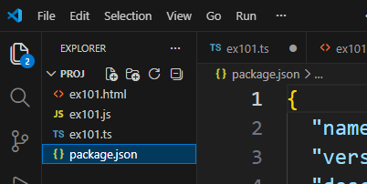
  - Under the Server terminal, type npm install --save-dev lite-server.
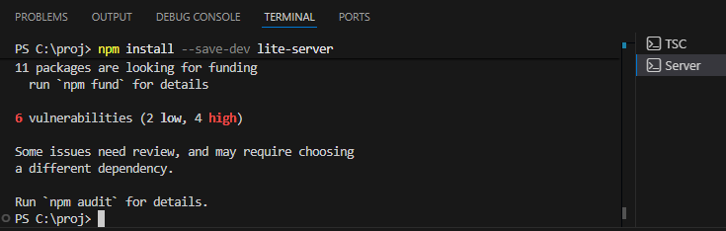
  - Under generated file package.json, add the following
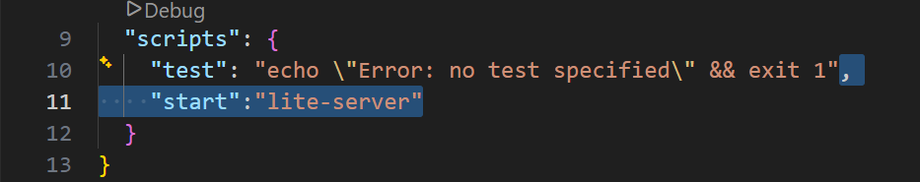
  - Save all files and run the command npm start under Server terminal.
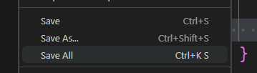
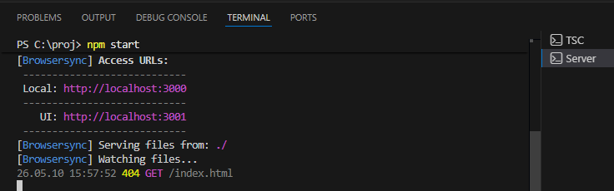
The Lite Server is running now.
Meanwhile, the default web browser is showing up
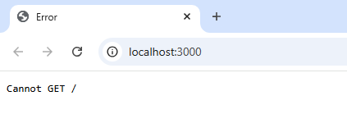
  - Don’t worry about the error now. Just manually change the URL to: http://localhost:3000/ex101.html.
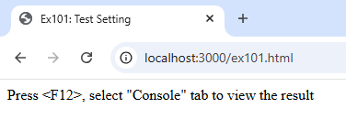
  - From browser, press F12 to show the Developer Pane.
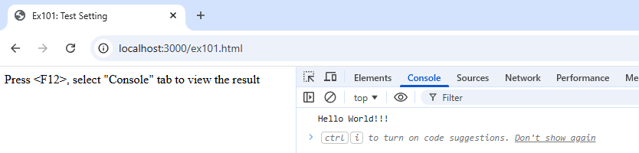
Notes: You can use F12 key to toggle the developer pane. The developer pane for most browsers using F12. If your browser can’t get the Developer Pane with F12, you need to find out which is the right key for it.

  - Under Server terminal, press <Ctrl>+C to stop the server
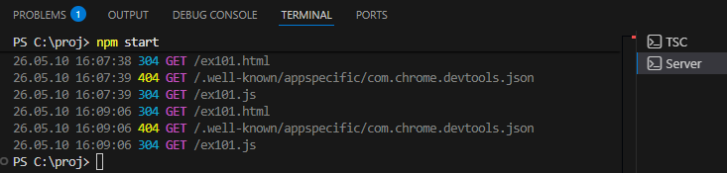

- Add a new index.html file
  - In explorer, add new file. Name the file as index.html, and prepare the following script:
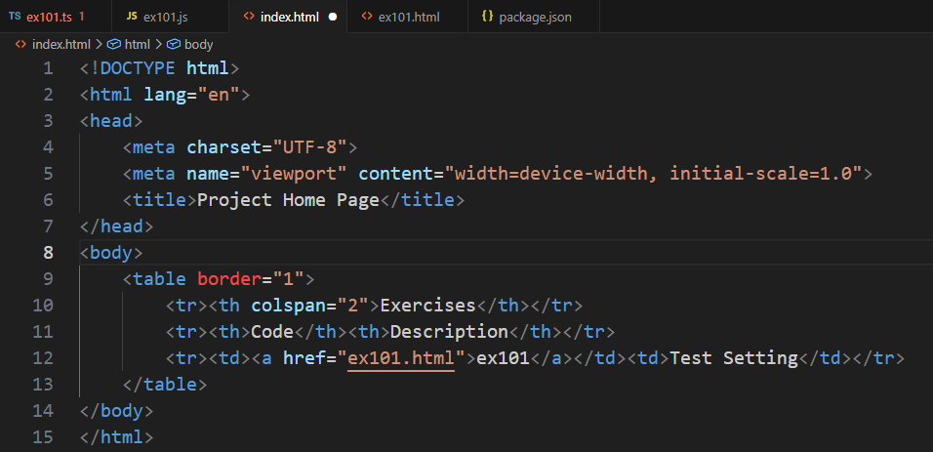
  - In package.json, change the main attribute:
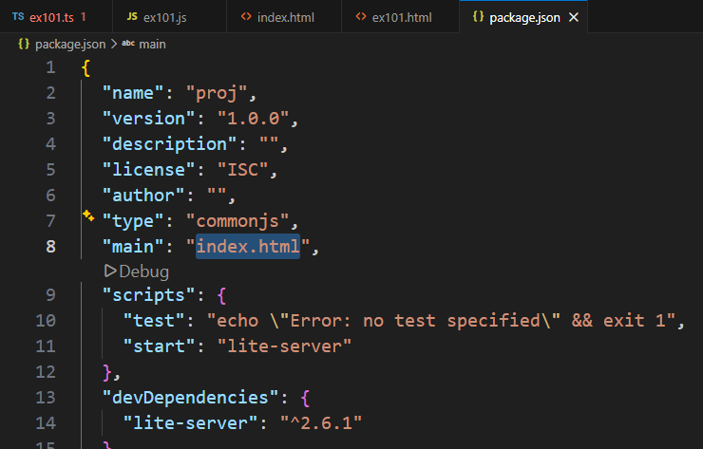
  - Save all files
  - Under Server terminal, use up arrow key or type npm start to run the server again. Now the browser launches index.html Home Page.
- Configure TypeScript compiler auto detect changes
  - Select the TSC terminal window, and type command tsc --init
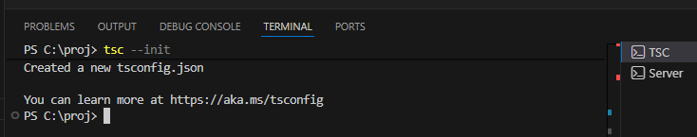
  - You will realize that tsconfig.json file is generated. Replace it with following script:
{
"compilerOptions": {
"module": "commonjs",
"target": "es2016",
"noImplicitAny": false,
"sourceMap": true,
"paths": {
// "*": ["node_modules/*", "src/types/*"]
}
},
"exclude": [
"node_modules",
"*.specs.ts"
]
}
  - Save all files, and type the command tsc -w under TSC terminal window:
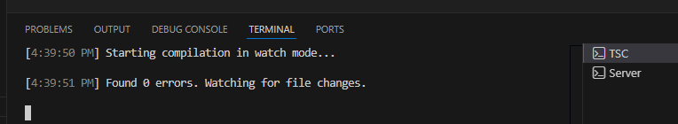
  - Now, the TypeScript compiler is now observing any TypeScript source file change, and it will automatically recompile them. To prove it works, edit the ex101.ts file:
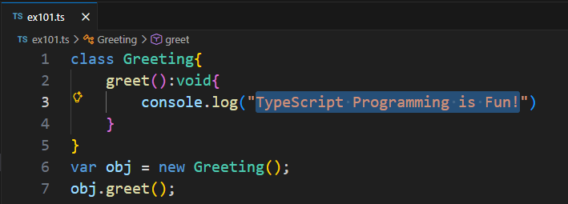
  - Save ex101.ts and observe the messages in TSC terminal window. Fix any problem until you get the following messages:
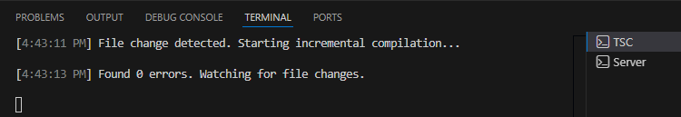
  - Switch to Server terminal. Type npm start to start the server again. In the home page click the ex101.html link
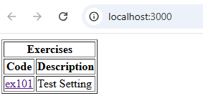
  - Press F12. You will see the updated message in console tab.
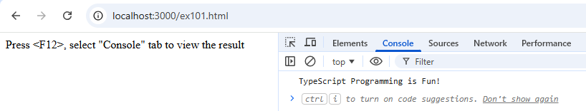
  - Switch back to ex101.ts editor, change the following, and save the file.
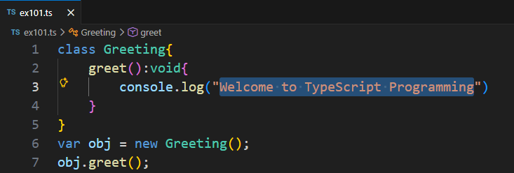
  - Switch back to browser, you will get updated message
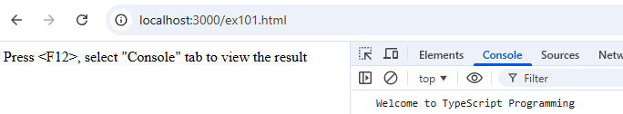
  - Close the browser, Shutdown the lite-server, close the Visual Studio Code

